Equivalence Partitioning

|  |  |  |
| --- | --- | --- |
| **Invalid** | **Valid** | **Invalid** |
| <=1 | 1-1000 | >=1000 |

|  |  |  |  |  |  |  |
| --- | --- | --- | --- | --- | --- | --- |
| **TC ID** | **TC Description** | **TC Input** | **Precondition** | **Expected Outcome** | **Actual Outcome** | **Status** |
| 1 | Verify that the given value of triangle is making isosceles triangle | Sides=”10, 10 ,15” | User must enter the three sides of triangle.  User must enter the values of sides in digits. | Given values is making isosceles triangle | Given values is making isosceles triangle | Pass |
| 2 | Verify that the given value of triangle is making equilateral triangle. | Sides=”7,7 ,7” | User must enter the three sides of triangle.  User must enter the values of sides in digits. | Given values is making equilateral triangle | Given values is making Equilateral triangle | Pass |
| 3 | Verify that the given value of triangle is making scalene triangle | Sides=”3, 4,5” | User must enter the three sides of triangle.  User must enter the values of sides in digits. | Given values is making scalene triangle | Given values is making scalene triangle | Pass |
| 4 | Verify that the given value and angle is making right angle triangle | Sides=”6,8 ,10”  Angle=”90” | User must enter the three sides of triangle.  User must enter the values of sides in digits.  User must enter the angle. | Given values is making Right-angle triangle | Given values is making Right-angle triangle | Pass |
| 5 | Verify that the given value is within the class | Sides=”  -1,4,6” | User must enter the three sides of triangle.  User must enter the values of sides in digits. | Given value is not making any triangle | Given value is making triangle | Fail |
| 6 | Verify that the given value is within the class | Sides=”  -1,4,6” | User must enter the three sides of triangle.  User must enter the values of sides in digits. | Given value is not making any triangle | Given value is not making triangle | pass |
| 7 | Verify that the given value is within the class | Sides=”  10001,4,6” | User must enter the three sides of triangle.  User must enter the values of sides in digits. | Given value is out of range | Given value is out of range | pass |
| 8 | Verify that the given value is within the class | Sides=”  10001,4,6” | User must enter the three sides of triangle.  User must enter the values of sides in digits. | Given value is out of range | Given value is making right triangle | Fail |
| 9 | Verify the area and perimeter of triangle | Sides=”7,7,7”  Height=”6”  Base=”4” | User must enter the height and base of triangle for Area.  User must enter the length of sides of triangle.  User must enter the values in digits and positive integer. | Area of triangle=12  Perimeter of triangle=21 | Area of triangle=12  Perimeter of triangle=21 | Pass |
| 10 | Verify the area and perimeter of triangle | Sides=”7,-,7”  Height=”6”  Base=”4” | User must enter the height and base of triangle for Area.  User must enter the length of sides of triangle.  User must enter the values in digits and positive integer. | Area of triangle=12  Please enter the value of third side | Area of triangle=12  Please enter the value of third side | Pass |
| 11 | Verify the area and perimeter of triangle | Sides=”7,-,7”  Height=”6”  Base=”4” | User must enter the height and base of triangle for Area.  User must enter the length of sides of triangle.  User must enter the values in digits and positive integer. | Area of triangle=12  Please enter the value of third side | Area of triangle=12  Perimeter of triangle=14 | Fail |
| 12 | Verify the area and perimeter of triangle | Sides=”7,  -1,7”  Height=”6”  Base=”4” | User must enter the height and base of triangle for Area.  User must enter the length of sides of triangle.  User must enter the values in digits and positive integer. | Area of triangle=12  Error the variable b should be positive | Area of triangle=12  Error the variable b should be positive | Pass |
| 14 | Verify the area and perimeter of triangle | Sides=”7,  -1,7”  Height=”6”  Base=”-1” | User must enter the height and base of triangle for Area.  User must enter the length of sides of triangle.  User must enter the values in digits and positive integer. | Error, the base should be positive to find Area.  Error the variable b should be positive. | Error the base should be positive to find Area.  Error the variable b should be positive. | Pass |
| 14 | Verify the area and perimeter of triangle | Sides=”7,  -1,7”  Height=”6”  Base=”” | User must enter the height and base of triangle for Area.  User must enter the length of sides of triangle.  User must enter the values in digits and positive integer. | Error, please Enter the value of Base to find Area  Error the variable b should be positive. | Error please Enter the value of Base to find Area .  Error the variable b should be positive. | Pass |

**Cause and effect Graph for Area**

**Cause:** C1=Base, C2= Height

**Effect:** Effect1=Area

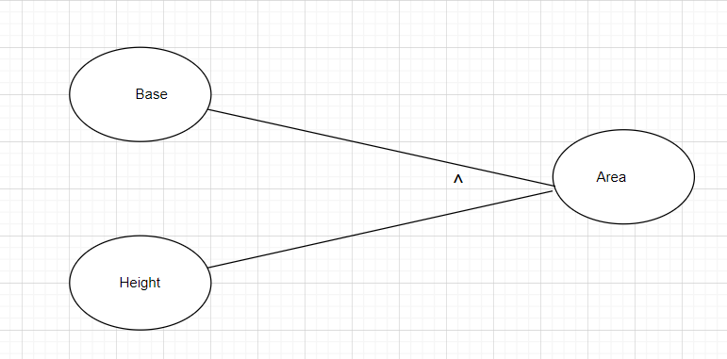

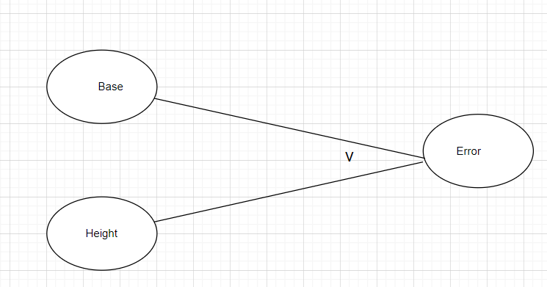

**Cause and effect Graph for Perimeter of Triangle**

**Cause:** C1=Side1, C2= Side1, C3=Side3

**Effect:** Effect=Perimeter

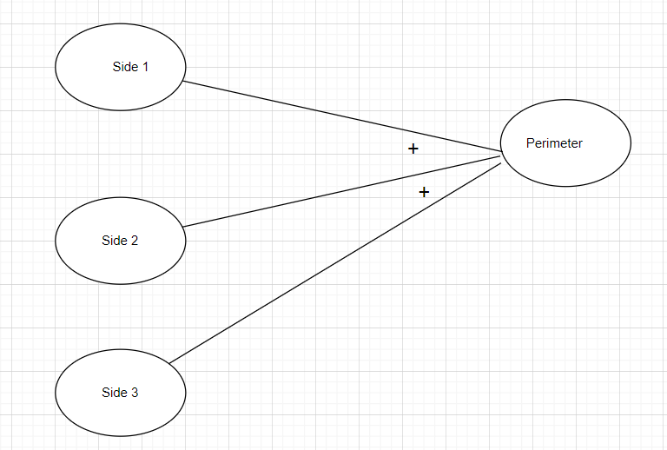

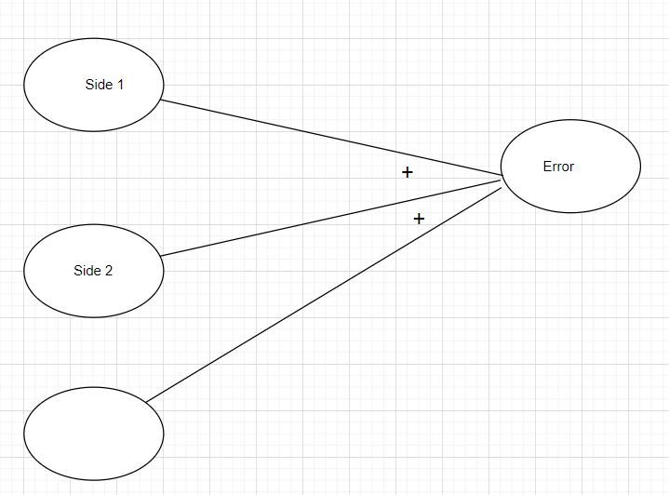

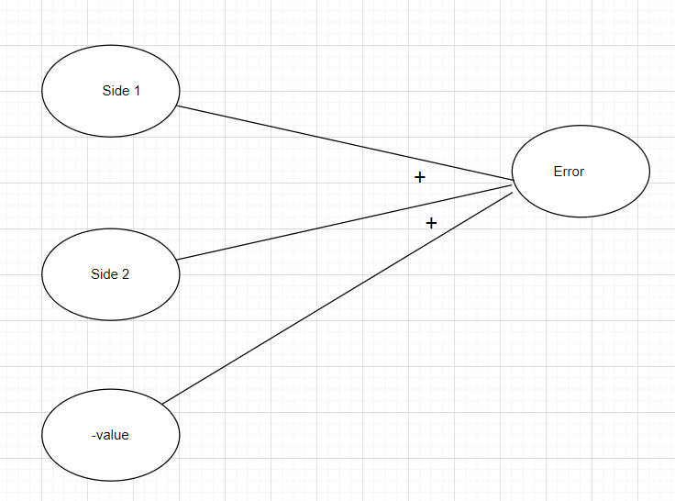

**Cause and effect Graph for Triangle Classification**

**Cause:** C1=Side1, C2= Side2, C3=side3

**Effect:** Effect1=Equilateral triangle, Effect2=Right-Angle triangle, Effect3=isosceles triangle, Effect4=Scalene triangle

